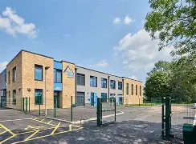

Special educational needs (SEN) information report – High Point Academy

Approved by: V. Drew |  | Date: 07/05/26
Last reviewed on: | 07/05/26
Next review due by: | Annually

What types of SEN does the school provide for?
High Point Academy provides education for pupils aged 11–16 with Education, Health and Care Plans (EHCPs). All pupils have a diagnosis of Autism Spectrum Condition (ASC) and may present with a range of additional needs.
Our school provides for pupils with the following needs:
- Communication and interaction needs, including speech, language and communication needs (SLCN)
- Cognition and learning needs, including moderate learning difficulties (MLD)
- Social, emotional and mental health (SEMH) needs
- Sensory and/or physical needs, including sensory processing difficulties
The school meets these needs through a structured, autism-specific environment, personalised pathways (Connector and Developer), specialist teaching approaches, and access to multi-agency support where appropriate.

Which staff will support my child, and what training have they had?
At High Point Academy, your child will be supported by a highly trained and experienced team who work together to meet their individual needs.
This includes:
- The SENCo, who leads on SEND provision, coordinates support and ensures all staff understand pupils’ needs
- The Senior Leadership Team, who oversee curriculum, behaviour and wellbeing
- Phase Leaders (Connector and Developer), who support teachers with curriculum adaptation and teaching strategies
- Teachers and Teaching Assistants, who work closely with pupils every day, delivering personalised support in lessons and interventions
- A Pastoral and Safeguarding Team, who support pupils’ emotional wellbeing and engagement
All staff have access to key information about pupils, including EHCPs, pupil profiles and Personal Learning Goals, ensuring support is consistent across the school.
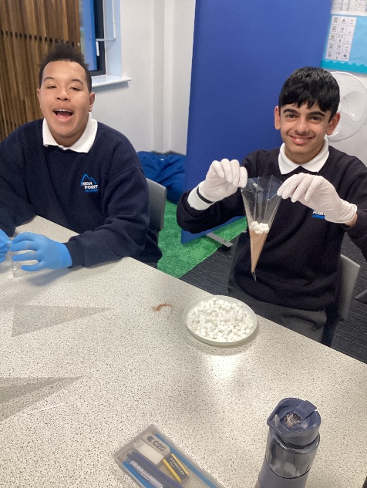

Our special educational needs co-ordinator, or SENCO
Our SENCo is Mrs Rebecca Richardson.
She is a qualified teacher with extensive experience in SEND and inclusion, having previously worked as a SENCo and Assistant Headteacher for Inclusion. She holds the National SENCo Award and a Level 7 qualification for access arrangements.
Mrs Richardson also teaches the NPQ SENCo programme through the National Institute of Teaching (NIoT) and has significant expertise in supporting pupils with autism, communication needs, SEMH and learning difficulties.
She works closely with staff, families and external agencies to ensure high-quality, personalised support for all pupils.
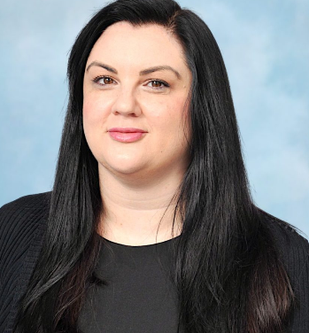

High Point Staff
All teachers and teaching assistants receive regular in-house SEND training and are supported by the SENCo to meet the needs of pupils with SEND. Teaching is adapted through personalised approaches, consistent routines and high expectations to ensure all pupils can access the curriculum. Staff use Teach Like a Champion strategies to strengthen teaching, improve engagement and promote inclusive practice across the school.
Staff also benefit from a wide range of external and specialist training, including:
- Speech and Language Therapy (SALT) training
- Trauma-informed practice and restorative approaches
- Zones of Regulation
- Phonics and reading interventions
- Safeguarding and contextual safeguarding training
- Inclusive attendance training
- Communication in Print and Makaton development
In addition, the school has trained Team Teach practitioners to support safe de-escalation and behaviour support, and staff trained in SEMH first aid to support pupils’ emotional wellbeing.
All training is delivered through a structured CPD programme across the year, ensuring staff continuously develop their knowledge and skills to meet pupils’ needs effectively.

External agencies and experts
Sometimes we need additional support to meet the needs of our pupils and their families. When appropriate, we work closely with a range of external professionals and services to ensure pupils receive the right level of support.
These include:
- Speech and Language Therapy (SALT) services
- Educational Psychology services (EP)
- Occupational Therapy (OT)
- Play therapy services
- Connexions (careers advice and guidance)
- The Albion Foundation (supporting communication, interaction and wellbeing)
- Social services and other local authority services
- School nursing services and health professionals where appropriate
We work in partnership with these agencies to assess needs, plan support and review progress, ensuring that advice is effectively implemented in school and shared with parents and carers.

How will the school measure my child’s progress?
We will follow the ‘graduated approach’ to meeting your child’s SEN needs.
The graduated approach is a 4-part cycle of assess, plan, do, review.
Review
We will assess how well the support we put in place helped the child to meet the outcomes we set. We will use our improved understanding of
your child’s needs to improve the support we offer.
Assess
If your child is not making the expected level of progress, we will make an assessment to find out what strengths and difficulties your child has. We will ask for input from you and your child, as well as getting help from external professionals where necessary.

Plan
In discussion with you and your child, we will decide what outcomes we are hoping to achieve. We will make a plan of the support we will offer your child to help them meet those outcomes. We will make a record of this and share it with you and all relevant school staff.
Do
We will put our plan into practice.
The class teacher, with the support of the SENCO, will be responsible for working with your child on a daily basis, and making sure the support we put in place is having the impact we intended.

As a part of the planning stage of the graduated approach, we will set outcomes that we want to see your child achieve.
Whenever we run an intervention with your child, we will assess them before the intervention begins. This is known as a ‘baseline assessment’. We do this so we can see how much impact the intervention has on your child’s progress.
We will track your child’s progress towards the outcomes we set over time and improve our offer as we learn what your child responds to best.
This process will be continual. If the review shows a pupil has made progress, they may no longer need the additional provision made. For others, the cycle will continue and the school's targets, strategies and provisions will be revisited and refined.

How will I be involved in decisions made about my child’s education?
We work closely in partnership with parents and carers to ensure you are fully involved in decisions about your child’s education.
You will receive annual written reports on your child’s progress, alongside regular updates throughout the year.
Your child’s class/form teacher will meet with you (e.g. parents’ evenings and EHCP reviews) to:
- Set clear outcomes for your child’s progress
- Review progress towards those outcomes
- Discuss the support in place to help your child achieve their goals
- Agree next steps, including what the school, you as parents/carers, and your child will do to support progress
You will also be involved in annual EHCP reviews, where your views are central to shaping provision and future planning.
Ongoing communication is maintained through Class Dojo, phone calls and meetings, ensuring you can share information, raise concerns and work in partnership with the school at all times.

How will my child be involved in decisions made about their education?
The level of involvement will depend on your child’s age and level of competence. We recognise that no 2 children are the same, so we will decide on a case-by-case basis, with your input.
We may seek your child’s views by asking them to:
- Attend meetings to discuss their progress and outcomes
- Discuss their views with a member of staff who can act as a representative during the meeting

How will the school adapt its teaching for my child?
Your child’s teacher is responsible and accountable for their progress and development. At High Point Academy, high-quality, inclusive teaching is the first step in meeting your child’s needs.
All pupils access a broad and balanced curriculum through our Connector and Developer pathways, which are designed to match pupils’ learning needs and prepare them for their next stage.
We adapt teaching, the curriculum and the learning environment to meet individual needs. There is no ‘one size fits all’ approach – adaptations are carefully planned on a case-by-case basis.
These adaptations may include:
- Differentiated curriculum delivery, including small group work, adapted tasks and personalised learning pathways
- Adapted teaching approaches, such as additional processing time, pre-teaching of vocabulary, modelling and structured questioning
- Consistent routines and visual supports, including now/next boards and clear lesson structures
- Use of specialist strategies, including Teach Like a Champion approaches to support engagement and understanding
- Adapted resources, such as laptops, iPads, visuals, scaffolds and alternative recording methods
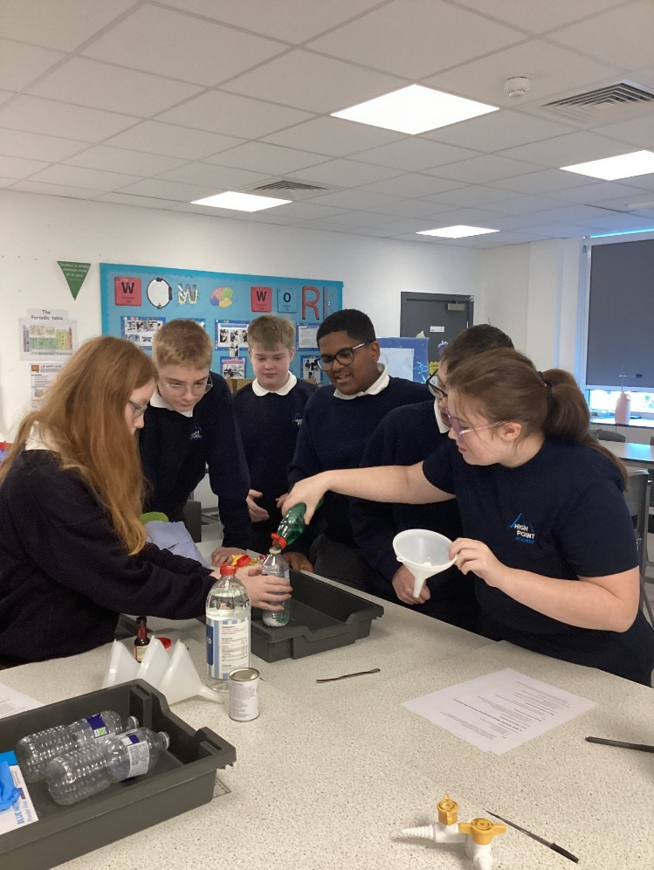

Name of intervention | SEN Area of Need | Intent
Phonics – Fresh Start | Cognition and Learning | To support pupils with developing early reading skills.
Cup of tea and chat | Social Emotional Mental Health | To support pupils who are experiencing short term difficulties and  could benefit from the opportunity to share their emotions with a trusted adult
Zones of Regulation | Social Emotional Mental Health | To support pupils who find it difficult to regulate their emotions. The intent is to help them to recognise and label emotions, know their triggers and strategies for self-regulation.
Handwriting | Cognition and Learning | To aid pupils who have difficulty forming letters correctly.
Play Therapy | Social Emotional Mental Health | External professional who works with pupils who have experienced ACES or  have an SEMH need. The intent is to explore traumatic  experiences/ strong emotions through structured play.
Peripatetic Guitar/Music Lessons | Preparing for Adulthood | To support a 5C pupil to develop a specific interest in music production and  prepare him for an audition for his chosen college course.
Reduced Timetable | Social Emotional Mental Health | To support pupils with EBSA or for whom a full school day is unmanageable
Restorative Visual Board | Social Emotional Mental Health | To support a pupil who finds it difficult to regulate his behaviour and  suffers from rejection sensitivity.
Animal Care | Social Emotional Mental Health/PFA/Life Skills | A therapeutic intervention for pupils who find caring for animals calming.  To aid pupils with developing life skills and preparing for adulthood by completing  tasks and taking on responsibilities.
Independent Travel Training | Preparing for Adulthood | To support pupils with being able to travel and use public transport safely.
Occupational Therapy | Sensory and Physical | To manage the OT needs of pupils to allow them to get the movement and exercise needed to stay regulated.
Sensory Circuit | Sensory and Physical | To manage the OT needs of pupils to allow them to get the movement and exercise needed to stay regulated.
Social Interactions | Communication and Interaction | To support pupils in developing positive communication skills with peers and staff
Exam Stress Workshop | Preparing for Adulthood | To support 5C pupils to manage the stress and anxieties they are experiencing in the  build up to exams and providing them with practical strategies they can use to help minimise negative feelings.
Lego Therapy | Communication and Interaction | To support pupils to develop communication and interaction skills with peers with a focus on working together and turn taking.
Comic Strip Conversations | Social Emotional Mental Health | To support pupils who find it difficult to communicate verbally and benefit from using pictures  to explore emotions and feelings.
Albion Foundation | Sensory and Physical | To work with pupils on physical fitness, promoting self-esteem and body image, teamwork and skill development.
Focuss Behaviour Support | Behaviour | To support staff and pupils through the use of targeted behaviour strategies and individualised behaviour support plans.
Personalised WorkStation | Cognition and Learning | To support pupils to access their learning within the classroom by minimising distractions  and providing a more individualised approach to work.
Seneca Learning | Cognition and Learning/Social Emotional Mental Health | An online learning platform used to support pupils who are struggling to remain in class, access the learning or who need to catch up or consolidate their learning of certain topics.
Behaviour Tracker | Behaviour | To support pupils who are finding it difficult to regulate their behaviour. Clear targets are set and monitored by a key member of staff.
Connexions | Preparing For Adulthood | To support KS4 pupils with post 16 choices – college/apprenticeship applications.
College | Preparing For Adulthood | To support KS4 pupils with the transition to post 16 provisions by allowing them to attend  college once a week to complete an Entry level qualification.

Monitoring by the SENCO
- Using provision maps to measure progress
- Holding an annual review (if they have an education, health and care (EHC) plan)

We provide all our pupils with appropriate advice on paths into work or further education.
We work with the pupil to help them achieve their ambitions, which can include goals in higher education, employment, independent living and participation in society.

What should I do if I have a complaint about my child’s SEN support?
If you have any concerns about your child’s SEND support, we encourage you to speak to us as soon as possible so we can resolve any issues quickly and effectively.
In the first instance, please contact your child’s class teacher or the SENCo. If your concern is not resolved, it will be referred to the Headteacher and managed in line with the school’s complaints procedure.
If you are not satisfied with the outcome, you can follow the next stages outlined in the school’s Complaints Policy, which is available on the school website. FET Policies - Forward Education Trust
If you feel your child has been discriminated against because of their SEND, you have the right to make a claim to the First-tier SEND Tribunal. Further information can be found at:
https://www.gov.uk/complain-about-school/disability-discrimination
You can make a claim relating to:
- Admissions
- Exclusion
- Provision of education and associated services
- Reasonable adjustments
Before accessing a tribunal, you may wish to use disagreement resolution or mediation services, which aim to resolve concerns collaboratively before they escalate.
For further information, see the SEND Code of Practice (pages 246–247).

What support is available for me and my family?
If you have any questions or need support, please contact the school. We are committed to supporting not only our pupils but also their families.
Additional support is available through local services:
- Sandwell Local Offer
https://www.sandwell.gov.uk/send
This provides information about services, support and opportunities available for children and young people with SEND and their families.
- SEND Information, Advice and Support Service (SENDIASS – Sandwell)
https://www.sandwellsendiass.co.uk
SENDIASS offers impartial advice and guidance on SEND processes, support and rights.
- • Walsall Local Offer
https://go.walsall.gov.uk/send-local-offer
- • Dudley Local Offer
https://www.dudley.gov.uk/residents/learning-school/sen-and-disability-local-offer
National charities that offer information and support to families of children with SEN are:
- IPSEA
- SEND family support
- NSPCC
- Family Action
- Special Needs Jungle

Glossary
- Access arrangements – special arrangements to allow pupils with SEN to access assessments or exams
- Annual review – an annual meeting to review the provision in a pupil’s EHC plan
- Area of need – the 4 areas of need describe different types of needs a pupil with SEN can have. The 4 areas are communication and interaction; cognition and learning; physical and/or sensory; and social, emotional and mental health needs
- CAMHS – child and adolescent mental health services
- Differentiation – when teachers adapt how they teach in response to a pupil’s needs
- EHC needs assessment – the needs assessment is the first step on the way to securing an EHC plan. The local authority will do an assessment to decide whether a child needs an EHC plan
- EHC plan – an education, health and care (EHC) plan is a legally-binding document that sets out a child’s needs and the provision that will be put in place to meet their needs
- First-tier tribunal / SEND tribunal – a court where you can appeal against the local authority’s decisions about EHC needs assessments or plans and against discrimination by a school or local authority due to SEN
- Graduated approach – an approach to providing SEN support in which the school provides support in successive cycles of assessing the pupil’s needs, planning the provision, implementing the plan, and reviewing the impact of the action on the pupil
- Intervention – a short-term, targeted approach to teaching a pupil with a specific outcome in mind
- Local offer – information provided by the local authority that explains what services and support are on offer for pupils with SEN in the local area
- Outcome – target for improvement for pupils with SEN. These targets don't necessarily have to be related to academic attainment
- Reasonable adjustments – changes that the school must make to remove or reduce any disadvantages caused by a child’s disability
- SENCO – the special educational needs co-ordinator
- SEN – special educational needs
- SEND – special educational needs and disabilities
- SEND Code of Practice – the statutory guidance that schools must follow to support children with SEND
- SEN information report – a report that schools must publish on their website, that explains how the school supports pupils with SEN
- SEN support – special educational provision that meets the needs of pupils with SEN
- Transition – when a pupil moves between years, phases, schools or institutions or life stages

